SIMATS ENGINEERING
CO3- AT2 - Design Task - Medium
NAME: A. Gopi Raj
REG: 192412453
COURSE NAME: Advance Wireless Communication Systems /5G / 6G Communication Systems
COURSE CODE: ECA5604
Design of a Low-Power Communication Model for Battery-Operated IoT Devices
Aim
To design a low-power communication model that enables battery-operated IoT devices to transmit data efficiently while minimizing energy consumption.
Objectives
- To design a communication model suitable for battery-operated IoT devices.
- To reduce energy consumption using sleep and wake-up mechanisms.
- To transmit sensor data only when required.
- To improve battery life through efficient communication.
- To simulate the proposed low-power model using MATLAB.
PROGRAM
clc;
clear;
close all;

%% Low-Power IoT Communication Model

T = 24; % Simulation time in hours
time = 1:T;

% Power consumption values
P_active = 100; % Active power (mW)
P_sleep = 5; % Sleep power (mW)

% Device activity: active for 1 hour, sleep for 3 hours
activity = [1 0 0 0 1 0 0 0 1 0 0 0 ...
1 0 0 0 1 0 0 0 1 0 0 0];

% Calculate power consumption
power = activity * P_active + (1-activity) * P_sleep;

% Total energy consumption
energy = sum(power); % mWh

%% Display Results
fprintf('LOW-POWER IoT COMMUNICATION MODEL\n');
fprintf('---------------------------------\n');
fprintf('Active Power = %d mW\n', P_active);
fprintf('Sleep Power = %d mW\n', P_sleep);
fprintf('Total Energy Consumption = %.2f mWh\n', energy);

%% Plot Power Consumption
figure;
stem(time, power, 'LineWidth', 1.5);
grid on;

xlabel('Time (Hours)');
ylabel('Power Consumption (mW)');
title('Power Consumption of Battery-Operated IoT Device');

%% Compare with Always Active Mode
alwaysActiveEnergy = T * P_active;
saving = ((alwaysActiveEnergy - energy) / alwaysActiveEnergy) * 100;

fprintf('Always Active Energy = %.2f mWh\n', alwaysActiveEnergy);
fprintf('Energy Saving = %.2f %%\n', saving); 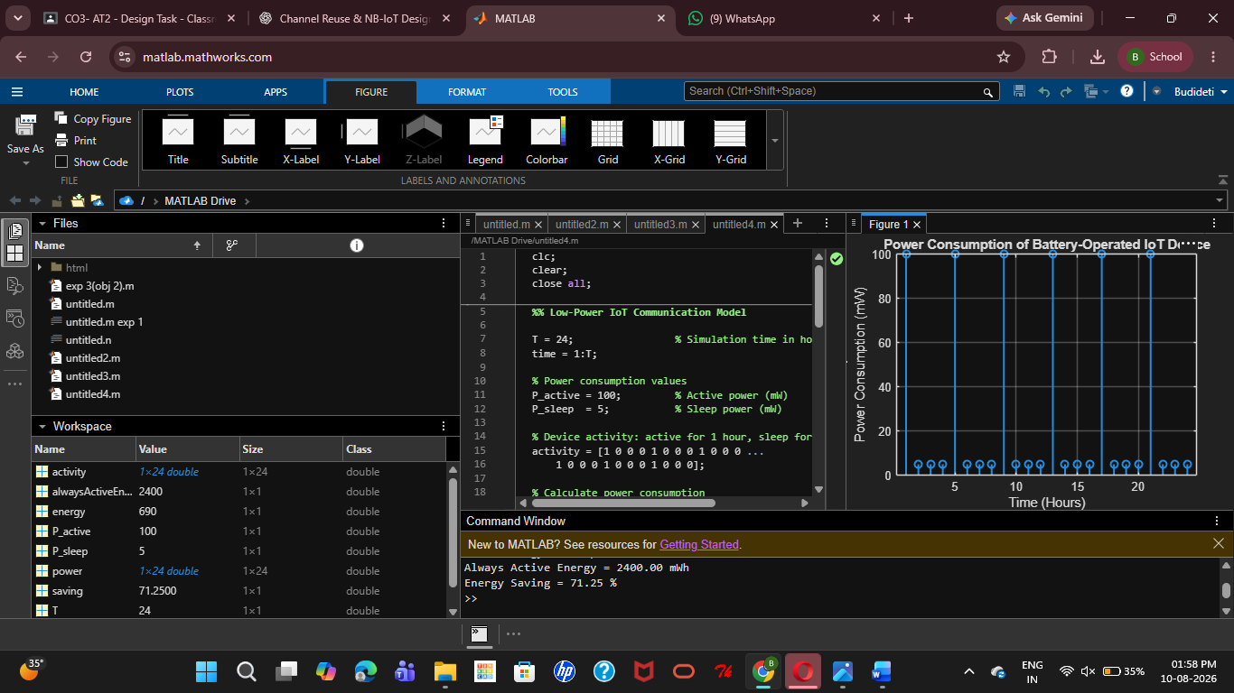
RESULT:
The low-power IoT communication model was successfully simulated in MATLAB. The sleep/wake-up mechanism reduced energy consumption by 71.25%, improving the battery efficiency of the IoT device.
25. Design an NB-IoT architecture for smart utility monitoring. (BL6)
Aim
To design an NB-IoT-based architecture for reliable and low-power monitoring of smart utility consumption.
Objectives
- To monitor electricity, water, or gas consumption.
- To transmit meter data using NB-IoT communication.
- To simulate utility data transmission using MATLAB.
- To enable remote monitoring of consumption.
- To improve energy efficiency and reduce manual meter reading.
PROGRAM
clc;
clear;
close all;

% Simulation parameters
T = 24; % 24 hours
time = 1:T;

% Simulated utility consumption
consumption = 2 + rand(1,T)*3;

% NB-IoT transmission
txData = consumption;

% Add small communication noise
rxData = txData + 0.05*randn(1,T);

% Display readings
disp('Smart Utility Monitoring using NB-IoT');
disp('--------------------------------------');

for i = 1:T
fprintf('Hour %02d : Consumption = %.2f units\n', ...
time(i), rxData(i));
end

% Plot monitoring data
figure;
plot(time,rxData,'-o','LineWidth',1.5);
grid on;
xlabel('Time (Hours)');
ylabel('Utility Consumption');
title('NB-IoT Smart Utility Monitoring');
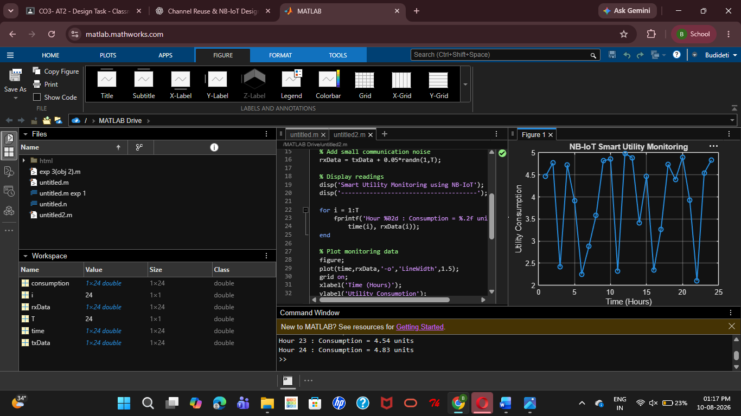
Result
The NB-IoT-based smart utility monitoring architecture was successfully simulated in MATLAB, enabling low-power data transmission and remote monitoring of utility consumption.

